Government of Karnataka
Department of technical education
College Name
Area name



Department of computer science & engineering
A Report on
“Electronic Pass (E-Pass) “
Submitted in partial fulfillment of the requirement of
Diploma in
COMPUTER SCIENCE AND ENGINEERING
For the academic year 2014-2015
Under the guidance of:
Guide name
Submitted by:
Stdudents name with Reg. No

College name
Simla Nagar, Hubli-580024

Department of Computer Science & Engineering
Year 2014-2015

CERTIFICATE OF APPROVAL OF PROJECT SYNOPSIS
Certified that this synopsis entitled “Electronic Pass(E-Pass)“which is being submitted by Names with Reg No. a student of “College name in partial fulfillment for the award of Diploma in computer science and engineering during the year 2014-2015 is record of students own work carried out under my/our guidance. It is certified that all corrections /suggestions indicated for internal assessments have been incorporated in the report. The project report has been approved as it satisfies the academic requirements in the respect of project work prescribed for said diploma. It is further understood that by this certificate the assigned do not endorse or approve any statement made, opinion expressed or conclusion drawn there in but approve the project only for the purpose for which it is submitted.

Mr. Guide name? Mr. HOD? Mr. Name? Project guide Head Of Department Principal

ABSTRACT:

Students are facing problems to get their bus pass. So this project provides a simple way to get the bus pass through online, this application helps student as well as KSRTC department to maintain the student record in digital form .E- Pass Generation system is a web application for students to get bus passes through online

INTRODUCTION

E- Pass Generation system is a web application for students to get bus passes through online This system was intended to develop an application for K, S.R.T.C to perform functionalities like accessing the basic information of a student from educational institutions for authentication and provide Bus pass to a particular student without placing him/her in a queue for a long time. This System keeps all information of all types Student Bus pass. Students are facing problems to get their bus pass. So this project provides a simple way to get the bus pass through online, this application helps student as well as KSRTC department to maintain the student record in digital form

Scope:

Using this system we can check all details related Bus pass and instruction like how to renew pass how to update it, and also provide details of student discount. This web portal involves online registration which would help the future implementation of various types of bus pass with ease.

Module:
This project Consist of the following modules.

1) Registration module
2) Login module
3) Admin module
4) Pass registration module
5) Payment gateway module
6) Pass generating module

FEATURES
  - Creating a new account for a new user/student
  - Login Authentication.
  - Validate student with all available details
  - Pass registration process
  - Transparency in Process.
  - Payment process.
  - Software is Platform Independent.
Modules Description

- Registration Module: This module is for the users who do not have their account. Here user is allowed to create an account to login. The account creation is done by filling the registration form with user/student’s details such as name, phone, college name, email etc.

- Login Module: This module has a drop down list box from where we have to select admin or student. The admin has all the rights in the software including updating the status of his site. The other fields in login are username and password. If the username and password are correct then it is directed to next page.

- Admin Module: This module is for the admin, where he verifies the identity of a User who wishes to access it. Since Access Control is normally based on the identity of the User who requests access to a resource, Authentication is essential to effective Security

- Pass registration Module: In this module, the online registration of bus pass is carried out as per the student’s needs/requirements.

- Payment Gateway Module: Further online payment for the bus pass is done within this module.

- Pass generating Module: In this module, final digital/soft copy of a bus pass is generated.

Environment:
OPERATING SYSTEMS

An operating system (OS) is software, consisting of programs and data, that runs on computers and manages computer hardware resources and provide common services for efficient execution of various application software.
For hardware functions such as input and output and memory allocation, the operating system acts as an intermediary between application programs and the computer hardware, although the application code is usually executed directly by the hardware and will frequently call the OS or be interrupted by it. Operating systems are found on almost any device that contains a computer from cellular phones and video game consoles to supercomputers and web servers.
Examples: Some of popular modern operating systems for personal computers are Linux/GNU, Mac OS X, and Microsoft Windows.
WINDOWS OPERATING SYSTEMS
Microsoft has taken two separate approaches with the Windows operating system: one is suited for home users while the other is intended for the IT professional. The dual approach has resulted in home editions having more functionality in the way of multimedia support. However, Microsoft home-based operating systems tend to have less functionality in regard to security and networking. The professional versions for the server environment are limited in multimedia features but offer enhanced networking capability and security.

WINDOWS NT:
The Windows NT operating system was released in July of 1993. This version was based on a new kernel and it was considered to be the first designed for a professional platform. NT was later upgraded to function as a home user operating system with the release of Windows XP.
WINDOWS 95:
In August of 1995, Windows 95 was released. This operating system offered a consumer solution with significant changes to the user interface that also utilized preemptive multitasking. Windows 95 was introduced to replace version 3.1 and Windows for Workgroups as well as MS-DOS. The first Microsoft operating system to use the plug and play system, Windows 95 revolutionized the desktop platform and achieved mass popularity.
WINDOWS 98:
Next up was Windows 98, released in June of 1998. This operating system was criticized for being slower and less reliable than version 95. Many of those issues were addressed a year later with the unveiling of Windows 98 Second Edition
Microsoft continued their line of professional operating systems with Windows 2000 in February of 2000. The consumer version was released as Windows ME in September of that year. ME integrated several new technologies, most notably the Universal Plug and Play.
WINDOWS XP:
Windows XP was released in October 2001. This version was based on the NT kernel and managed to retain the extreme functionality of its home-based predecessors. XP was widely embraced by the public and came in two different editions: Home and Professional. The Home Edition provided exceptionable multimedia support while the Professional edition offered excellent security and networking capabilities. XP has since been succeeded by Vista but support will continue through April of 2009.
The Microsoft operating system received a tremendous upgrade with Windows Vista on January 30, 2007. This version includes several new features with an emphasis on security. Vista offers an improved shell design and user interface along with numerous technical modifications. Despite its functionality, Windows Vista has received criticism.
WINDOWS-7:
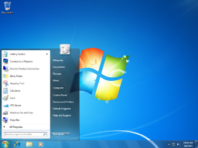

Windows 7: shown here, is the newest release of Windows.
Microsoft Windows is a family of proprietary operating systems most commonly used on personal computers. It is the most common family of operating systems for the personal computer, with about 90% of the market share. Currently, the most widely used version of the Windows family is Windows XP, released on October 25, 2001. The newest version is Windows 7 for personal computers and Windows Server 2008 R2 for servers.
Microsoft Windows originated in 1981 as an add-on to the older MS-DOS operating system for the IBM PC. First publicly released in 1985, Windows came to dominate the business world of personal computers, and went on to set a number of industry standards and commonplace applications. Beginning with Windows XP, all modern versions are based on the Windows NT kernel.
KERNEL:
The kernel is a program that constitutes the central core of a computer operating system. It has complete control over everything that occurs in the system. A kernel can be contrasted with a shell (such as bash, csh or ksh in Unix-like operating systems), which is the outermost part of an operating system and a program that interacts with user commands.
The kernel itself does not interact directly with the user, but rather interacts with the shell and other programs as well as with the hardware devices on the system, including the processor i.e., memory and disk drives. The kernel is the first part of the operating system to load into memory during booting (i.e., system startup), and it remains there for the entire duration of the computer session because its services are required continuously.
Thus it is important for it to be as small as possible while still providing all the essential services needed by the other parts of the operating system and by the various application programs. The firmware and device drivers, the operating system provides the most basic level of control over all of the computer's hardware devices. It manages memory access for programs in the RAM, it determines which programs get access to which hardware resources, it sets up or resets the CPU's operating states for optimal operation at all times, and it organizes the data for long-term non-volatile storage with file systems on such media as disks, tapes, flash memory, etc.
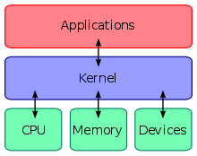

Fig: KERNEL

SYSTEM ANALYSIS
Existing System:
Before this application implementation the manual process is used to do the process of issuing the Bus pass to the students. This Manual process requires man power and more time consuming. To avoid such difficulties we implemented this system.

Drawbacks:
- The student should have access to internet to access/open the website.
- The students applying for a bus pass needs to provide their or his/her parents/guardians debit card account information to complete the purchase.
- Initially data has to be computerized.

Proposed System:

The main objective of this project is to develop a web application which provide a hassle free experience of online registration of a bus pass to a student by providing a online web portal through which we can apply for bus pass by providing his/her college identity details going through an online secure payment gateway and as well as a registration of an account on this website, so they can login and easily manage their profile information and can obtain their bus pass, without overhead.

Architecture Analysis:
Database Analysis:
Database design is an important place in designing a system. During this phase care should be taken to avoid redundancy of information storing into a database, since it leads to wastage of memory space.

2.4.1. Normalization Techniques:
Normalization is a process of simplifying the relationship between data elements in a record. Through normalization a collection of data in a records structure is replaced by successive record structures that are simpler and more predictable and therefore more manageable.
- First Normal Form
A relation is said to be in first normal form if the values in the relation are atomic for every attribute in the relation .By this we mean simply that no attribute value can be a set of values or as it sometimes expressed, a repeating group.
- Second Normal Form
A relation is said to be in second normal form if it is in first normal form and it should satisfy any one of the following rules.
Primary key is a not a composite primary key
No non-key attribute is fully functionally dependent on full set of primary key
- Third Normal Form
A relation is said to be in third normal form if it is in second normal form and if their exits no transitive dependencies
- Transitive Dependency
If two non-key attributes depends on each other as well as on the primary key then they are said to be transitively dependent. the above normalization principles where applied to decompose the data in multiple tables there by making the data to be maintained in a consistent state.

Logical Database Design
Table Definitions:

DATABASE DESIGN:
MSTR_LOGIN:

FIELD | DATATYPE | NULL? | KEY
USER ID | VARCHAR(30) | NULL | 1
PASSWORD | VARCHAR(30) | NULL | 0
STATUS | VARCHAR(30) | NULL | 0
LAST_LOGINDATETIME | DATETIME | NULL | 0
STUDENT_DETAILS:
FIELD | DATATYPE | NULL? | KEY
FNAME | VARCHAR(30) | NULL | 1
LNAME | VARCHAR(30) | NULL | 0
EMAIL | VARCHAR(30) | NULL | 0
GENDER | VARCHAR(30) | NULL | 0
BDATE | DATE | NULL | 1
ADDRESS | VARCHAR(30) | NULL | 0
CITY | VARCHAR(30) | NULL | 0
ZIPCODE | VARCHAR(30) | NULL | 0
PHONE | VARCHAR(30) | NULL | 0
MOBILE | VARCHAR(30) | NULL | 0

PASS TABLE:

FIELD | DATATYPE | NULL? | KEY
APPLICAATION ID | VARCHAR(30) | NULL | 1
FNAME | VARCHAR(30) | NULL | 0
LNAME | VARCHAR(30) | NULL | 0
EMAIL | VARCHAR(30) | NULL | 0
GENDER | VARCHAR(30) | NULL | 0
BDATE | DATE | NULL | 1
COLLEGE NAME | VARCHAR(30) | NULL | 0
ADDRESS | VARCHAR(30) | NULL | 0
CITY | VARCHAR(30) | NULL | 0
ZIPCODE | VARCHAR(30) | NULL | 0
PHONE | VARCHAR(30) | NULL | 0
MOBILE | VARCHAR(30) | NULL | 0
FROM | VARCHAR(30) | NULL | 0
TO | VARCHAR(30) | NULL | 0
STUDENTPHOTOS | VARCHAR(30) | NULL | 0
ADDRESSPROF | VARCHAR(30) | NULL | 0
PAYMENT | VARCHAR(30) | NULL | 0

KSRTC ADMIN:
FIELD | DATATYPE | NULL? | KEY
APPLICAATION ID | VARCHAR(30) | NULL | 1
FNAME | VARCHAR(30) | NULL | 0
LNAME | VARCHAR(30) | NULL | 0
EMAIL | VARCHAR(30) | NULL | 0
GENDER | VARCHAR(30) | NULL | 0
BDATE | DATE | NULL | 1
COLLEGE NAME | VARCHAR(30) | NULL | 0
ADDRESS | VARCHAR(30) | NULL | 0
CITY | VARCHAR(30) | NULL | 0
ZIPCODE | VARCHAR(30) | NULL | 0
PHONE | VARCHAR(30) | NULL | 0
MOBILE | VARCHAR(30) | NULL | 0
FROM | VARCHAR(30) | NULL | 0
TO | VARCHAR(30) | NULL | 0
STUDENTPHOTOS | VARCHAR(30) | NULL | 0
ADDRESSPROF | VARCHAR(30) | NULL | 0
PAYMENT | VARCHAR(30) | NULL | 0

PAYMENT:
FIELD | DATATYPE | NULL? | KEY
APPID | VARCHAR(30) | NULL | 1
NAME | VARCHAR(30) | NULL | 0
CARD | VARCHAR(30) | NULL | 0
PIN | VARCHAR(30) | NULL | 0
AMOUNT | VARCHAR(30) | NULL | 0

SYSTEM CONFIGURATON
The selection of hardware is very important in the existence and proper working of any software. When selecting hardware, the size and requirements are also important.

Software Requirements:
- Operating system : Windows XP or any latest version of windows
- Web Browser : Mozilla Firefox or any browser
- Front- End : PHP
- Back- End : MySQL
- Technology : PHP Scripting Technology
- Code-Behind Language : JavaScript validation
- IDE : Dreamweaver / Netbeans
- Server : WAMP, Mysql Server

Project will be done in PHP as front end and MySQL as back end.

Hardware Requirements:
Processor : INTEL Pentium 4
RAM : 512MB
Hard Disk Drive : 40GB

SELECTED SOFTWARE DETAILS
PHP:
Since the Internet is packed with millions of acronyms, PHP is another one! PHP stands for PHP: Hypertext Preprocessor. Yes, the acronym is recursive and for the purposes of this class, we will just call it “PHP.”
PHP is a server-side scripting language and is very similar to C, Java, and Perl. PHP allows the Programmer to dynamically generate content, instead of statically like regular ‘ol’ HTML. This tutorial will cover uses of PHP from simple data processing of forms to parsing a page for relevant information.
PHP Hosts:
Free webhosting services with PHP exist, but a function like sending e-mail is probably disabled. Stanford (fortunately) provides limited PHP support sufficient enough for the scope of this course
PHP is free, nonproprietary and more than 6 million web sites use PHP. It is the second most popular scripting language and its use is growing faster than any other scripting language. Based on search engine popularity PHP’s growth per year is 4694% compared to ASP growth of 278%.
PHP is available on approx 40% of all Apache Servers. PHP is suited to development of ecommerce sites and a wide range of database connectivity. PHP runs on UNIX, Windows and Mac platforms. PHP can also be used to create shockwave, PDF files and parse XML. PHP was developed so it could be to inserted directly into HTML documents.
Embedding PHP into HTML includes:
1) Quicker response time
2) Improved security
3) Transparency to the end user
- PHP language syntax is borrowed from C with elements of Perl, C++ and Java.
- PHP is also integrates easily with MySQL which is a free non-proprietary database. MySQL can be used to create large powerful databases and because it is free is often favored by non-profit organizations.

Introduction to PHP4:
PHP is a server side HTML embedded scripting language that allows you to make web sites dynamic, connect to databases, process forms and adds many other features to your web site.
Before you create web pages with PHP you need to the following items:
1) Install a server on your computer e.g. Microsoft IIs, Apache or Omnipro
2) Download, install and configure PHP (it’s free)
3) You will require an Internet account that supports PHP
4) If you plan to work with MySQL you ISP will need to offer this feature (MySQL is free, but MySQL hosting usually is not) – you can test your database locally
Since MS IIs server comes with Windows OS, we will be using this server, you can use any server but each server requires its own setup and configuration. Also if you put more than one server on your computer make sure they are not running simultaneously. On a good day server installation and PHP installation takes about 15 minutes. On a bad day it can take quite a bit longer..
<Html>
<Head>
<Title>Test</title>
<Body>
<Center><h1>your server is working</h1></center>
</body>
</html>
Save the file in the folder Wamp/wwwroot and name it test.html
Open your browser and load the file by typing in:
http://localhost/test.html

2) Go to www.php.net>downloads>find or the latest version of PHP and download PHP 4.3.4 installer [1,043Kb] (CGI only, MySQL support built-in, packaged as Windows installer to install and configure PHP, and automatically configure IIS, PWS and Xitami, with manual configuration for other servers. N.B. no external extensions included) you should turn the IIs server off before installing, and then turn back on after you installed PHP.

3) Test whether or not PHP is working creates a small file and save it inside the www root folder inside wwwroot.
Use Note page create the PHP test file
<? Php
Phpinfo ();
?>
Save as test.php or phpinfo.php then using your browser: type in the URLhttp://localhost/php.info ();
If PHP is working you will see a screen with PHP version 4.3 and all of its features – if you don’t, check that the server is on, uninstall and install PHP again.

4) Finally you need to configure the php.ini file stored in your c:\WINNT folder go to this folder and select show all files>view as a list (not your WINNT folder may be on a drive other than C :\). Double click on the php.ini file or load the file into notepad. This file configures php and its settings. You should read it at least once to know what is in there but to start you need to modify 3 settings on your computer. Use Notepad find feature to locate these lines of code.
a) Cgi.force_redirect=0; (set to 0 i.e. false is required to work on IIs)
b) Error reporting = E_ALL change to
Error reporting = E_ALL &~ (E_NOTICE | E_USER_NOTICE);
If you don’t do this when you create forms you will get undefined variable errors
c) Register_globals = On
(or = 1) you will read this is a security risk, which is true if you used your machine for a server on the Internet but if you are only using if for testing don’t worry. You need to do this so you don’t get undefined variables with forms).

We will download, install and configure MySQL at a later time.
Another possible problem that could arise on some machines is that you must turn the file permission for www.root file on. Right click on the folder>properties> make sure the file sharing is turned on.
On some machines at SAIT the IIS files are on the machine inside I386 folder. Also make sure if Apache is on the machine it is turned off.

The following are some advantages of using someone else’s Web environment:
- It’s easier than setting up your own: You just copy your Web pages onto the other party’s computer, and that’s it. You don’t need to install any software or hardware or resolve any computer problems. Someone else handles that for you.
- Less technical skill is required: You need to understand only Web languages, such as HTML and PHP. You don’t need to know about Internet connections, Web servers, computer administration, and other technical things. Some people are very interested in these things, but some are not.

The advantages of running your own Web environment are as follows:
- Control: You get to make all the decisions. You can set up the Web environment the way that works best for you.
- Access: You can access the computer whenever you want to work on your Web site.
- Stability: You know the Web site will be there as long as you need it. You won’t wake up one morning to discover that your Web hosting company has gone out of business and you have two days to move your site.
- Security: Because you control the Web environment, you are the only person who needs to access the computer. You can keep it under lock and key. When you use a Web hosting company, other people have access to the computer, and one of them may be a bad guy who’s after your secrets.

PHP has many features designed specifically for use in Web sites, including the following:
- Interact with HTML forms: PHP can display an HTML form and process the information that the user types in.
- Communicate with databases: PHP can interact with databases to store information from the user or retrieve information that is displayed to the user.
- Generate secure Web pages: PHP allows the developer to create secure Web pages that require users to enter a valid username and password before seeing the Web page content.
PHP features make these and many other Web page tasks easy. PHP is only server-side, meaning it can’t interact directly with the user’s computer. That means PHP can’t initiate actions based on the status of the user’s computer, such as mouse actions or screen size. Therefore, PHP alone can’t produce some popular effects, such as navigation menus that drop down or change color. On the other hand, JavaScript, a client-side scripting language, can’t access the server, limiting its possibilities. For example, you can’t use JavaScript to store data on the server or retrieve data from the server. But wait! You don’t have to choose. You can use JavaScript and PHP together to produce Web pages that neither can produce alone. See Chapter 11 for details on using JavaScript and PHP together.
HTML:
HTML, which stands for Hypertext Markup Language, is the predominant markup language for web pages. HTML is the basic building-blocks of webpage.
HTML is written in the form of HTML elements consisting of tags, enclosed in angle brackets (like <html>), within the web page content. HTML tags normally come in pairs like <h1> and </h1>. The first tag in a pair is the start tag, the second tag is the end tag (they are also called opening tags and closing tags).
The purpose of a web browser is to read HTML documents and compose them into visual or audible web pages. The browser does not display the HTML tags, but uses the tags to interpret the content of the page.
HTML elements form the building blocks of all websites. HTML allows images and objects to be embedded and can be used to create interactive forms. It provides a means to create structured documents by denoting structural semantics for text such as headings, paragraphs, lists, links, quotes and other items. It can embed scripts in languages such as JavaScript which affect the behavior of HTML WebPages.
Web browsers can also refer to Cascading Style Sheets (CSS) to define the appearance and layout of text and other material. The W3C, maintainer of both the HTML and the CSS standards, encourages the use of CSS over explicitly presentational HTML markup.
MARKUP:
HTML markup consists of several key components, including elements (and their attributes), character-based data types, character references and entity references. Another important component is the document type declaration, which triggers standards mode rendering.
The Hello world program, a common computer program employed for comparing programming languages, scripting languages and markup languages is made of 9 lines of code although in HTML newlines are optional:
Example:
<! doctype html>
<Html>
<Head>
<Title>Hello HTML</title>
</head>
<Body>
<p>Hello World! </p>
</body>
</html>
MYSQL:
MySQL is a relational database management system (RDBMS that runs as a server providing multi-user access to a number of databases. MySQL is officially pronounced ("My S-Q-L"), but is often also pronounced ("My Sequel"). It is named after developer Michael Widenius daughter, my. The SQL phrase stands for Structured Query Language.
The MySQL development project has made its source code available under the terms of the GNU General Public License, as well as under a variety of proprietary agreements. MySQL was owned and sponsored by a single for-profit firm, the Swedish company MySQL AB, now owned by Oracle Corporation.
Free-software projects that require a full-featured database management system often use MySQL. For commercial use, several paid editions are available, and offer additional functionality. Some free software project examples: Joomla, Word Press, MyBB, phpBB, Drupal and other software built on the LAMP software stack. MySQL is also used in many high-profile, large-scale World Wide Web products, including Wikipedia, Google (though not for searches) and Face book.
USE:
MySQL is a popular choice of database for use in web applications, and is a central component of the widely used LAMP web application software stack—LAMP is an acronym for "Linux, Apache, MySQL, and Perl/PHP/Python".

PLATFORMS AND INTERFACES:
MySQL is written in C and C++. Its SQL parser is written in yacc, and a home-brewed lexical analyzer named sql_lex.cc.
MySQL works on many different system platforms, including AIX, BSDi, FreeBSD, HP-UX, eComStation, i5/OS, IRIX, Linux, Mac OS X, Microsoft Windows, NetBSD, Novell NetWare, OpenBSD, Open Solaris, OS/2 Warp, QNX, Solaris, Symbian, SunOS, SCO Open Server, SCO UnixWare, Sanos and Tru64. A port of MySQL to OpenVMS also exists.
Many programming languages with language-specific APIs include libraries for accessing MySQL databases. These include MySQL Connector/Net for integration with Microsoft's Visual Studio (languages such as C# and VB are most commonly used) and the ODBC driver for Java. In addition, an ODBC interface called MyODBC allows additional programming languages that support the ODBC interface to communicate with a MySQL database, such as ASP or ColdFusion.
The HTSQL - URL based query method also ships with a MySQL adapter, allowing direct interaction between a MySQL database and any web client via structured URLs. The MySQL server and official libraries are mostly implemented in ANSI C/ANSI C++.
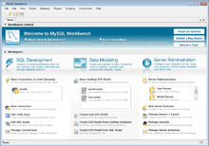
Fig: MYSQL

DEPLOYMENT:
MySQL can be built and installed manually from source code, but this can be tedious so it is more commonly installed from a binary package unless special customizations are required. On most Linux distributions the package management system can download and install MySQL with minimal effort, though further configuration is often required to adjust security and optimization settings.
Though MySQL began as a low-end alternative to more powerful proprietary databases, it has gradually evolved to support higher-scale needs as well. It is still most commonly used in small to medium scale single-server deployments, either as a component in a LAMP based web application or as a standalone database server. Much of MySQL's appeal originates in its relative simplicity and ease of use, which is enabled by an ecosystem of open source tools such as phpMyAdmin.
In the medium range, MySQL can be scaled by deploying it on more powerful hardware, such as a multi-processor server with gigabytes of memory. There are however limits to how far performance can scale on a single server, so on larger scales, and multi-server MySQL deployments are required to provide improved performance and reliability. A typical high-end configuration can include a powerful master database which handles data write operations and is replicated to multiple slaves that handle all read operations.
The master server synchronizes continually with its slaves so in the event of failure a slave can be promoted to become the new master, minimizing downtime. Further improvements in performance can be achieved by caching the results from database queries in memory using memcached, or breaking down a database into smaller chunks called shards which can be spread across a number of distributed server clusters.

COMMAND LINE:
MySQL ships with a suite of command-line tools for tasks such as querying the database, backing up data, inspecting status, performing common tasks such as creating a database, and many more. A variety of third-party command-line tools is also available, including Maatkit, which is written in Perl.
FORKS OF MYSQL:
- Drizzle – a fork targeted at the web-infrastructure and cloud computing markets. The developers of the product describe it as a "smaller, slimmer and (hopefully) faster version of MySQL". As such is planned to have many common MySQL features stripped out, including stored procedures, query cache, prepared statements, views, and triggers.
- MariaDB – a community-developed branch of the MySQL database, the impetus being the community maintenance of its free status under GPL as opposed to any uncertainty of MySQL license status under its current ownership by Oracle. The intent also being to maintain high fidelity with MySQL, ensuring a "drop-in" replacement capability with library binary equivalency and exacting matching with MySQL APIs and commands. It includes the XtraDB storage engine as a replacement for InnoDB.
- Percona Server – a fork that includes the XtraDB storage engine. It is an enhanced version of MySQL that is fully compatible, and deviates as little as possible from it, while still providing beneficial new features, better performance, and improved instrumentation for analysis of performance and usage.
- Our Delta– is best characterized as a source of binaries compiled with various patches, including patches from MariaDB, Percona, and Google.
- Solution Stack In computing, a solution stack is a set of software subsystems or components needed to deliver a fully functional solution, e.g. a product or service.

DATABASE ENGINE
A database engine (or "storage engine") is the underlying software component that a database management system (DBMS) uses to create, read, update and delete (CRUD) data from a database. Most database management systems include their own Application Programming Interface (API) that allows the user to interact with their underlying engine without going through the user interface of the DBMS.
Many of the modern DBMS supports multiple database engines within the same database. For example, MySQL supports InnoDB as well as MyISAM Some database engines are transactional. Such as Follows
NAME | FREE | TRANSACTIONAL
Blitz DB | GPL | No
Falcon | GPL | Yes
Inno DB | GPL | Yes
Maria | GPL | No
MyISAM | GPL | No
Xtra DB | GPL | Yes
Fig: Database Engines
INNO DB:
InnoDB is the default storage engine for MySQL as of MySQL 5.5. It provides the standard ACID-compliant transaction features, along with foreign key support (Declarative Referential Integrity). It is included as standard in most binaries distributed by MySQL AB, the exception being some OEM versions.
InnoDB became a product of Oracle Corporation after their acquisition of Innobase Oy in October 2005. The software is dual licensed; it is distributed under the GNU General Public License, but can also be licensed to parties wishing to combine InnoDB in proprietary software.
MYISAM:
MyISAM was the default storage engine for the MySQL relational database management system versions prior to 5.5.It is based on the older ISAM code but has many useful extensions. The major deficiency of MyISAM is the absence of transactions support. Versions of MySQL 5.5 and greater have switched to the InnoDB engine to ensure referential integrity constraints, and higher concurrency.
Each MyISAM table is stored on disk in three files. The files have names that begin with the table name and have an extension to indicate the file type. MySQL uses a .frm file to store the definition of the table, but this file is not a part of the MyISAM engine, instead it is a part of the server. The data file has a .MYD (MYData) extension. The index file has a .MYI (MY Index) extension.
ISAM:
ISAM stands for Indexed Sequential Access Method, a method for indexing data for fast retrieval. ISAM was originally developed by IBM for mainframe computers. Today the term is used for several related concepts:
- Specifically, the IBM ISAM product and the algorithm it employs.
- A database system where an application developer directly uses an Application Programming Interface to search indexes in order to locate records in data files. In contrast, a relational database uses a query optimizer which automatically selects indexes.
- An indexing algorithm that allows both sequential and keyed access to data. Most databases now use some variation of the B-Tree for this purpose, although the original IBM ISAM and VSAM implementations did not do so.
- Most generally, any index for a database. Indexes are used by almost all databases, both relational and otherwise.

SYSTEM DESIGN
UML Diagrams
The Unified Modeling Language (UML) is the industry-standard modeling language used for specifying, visualizing, constructing and documenting the artifacts of a software system. The UML is also effective for modeling business and other Non-software systems.
One of the major goals of UML is to present a common modeling language that all developers can use. It is a language whose vocabulary and rules focus on the conceptual and physical representation of the system.
The UML uses Diagram to represent different views of the system being modeled. The purpose of diagram is to present a set of modeled elements, which are rendered as shapes and connectors.
Every complex system is best approached through a small set of nearly independent views of a model; No single viewer is sufficient. Every model may be expressed at different levels of fidelity. The best models are connected to reality.
The UML defines nine graphical diagrams:
1. Use-Case Diagram
2. Activity Diagram
3. Data flow Diagrams
4. ER Diagram
Use case diagrams:
A use case is a description of a set of sequences of actions, including variants that a system performs to yield an observable result of value to an actor.
A use case involves the interaction of actors and the system. An actor represents a coherent set of roles that users of use case play when interacting with these use cases. Actors can be human are they can be automated systems.

Use-Case Diagram
Student Use-Case Diagram

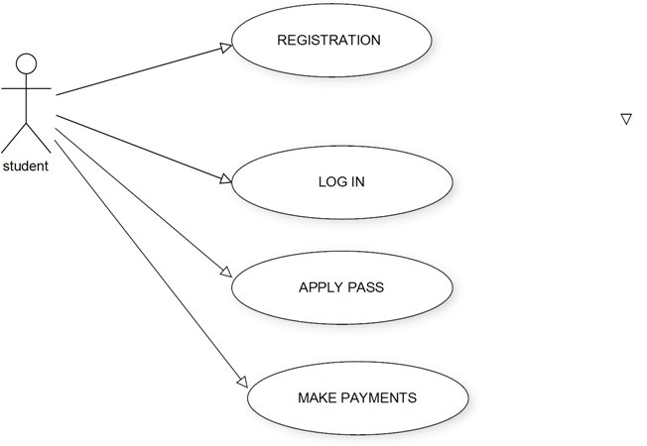

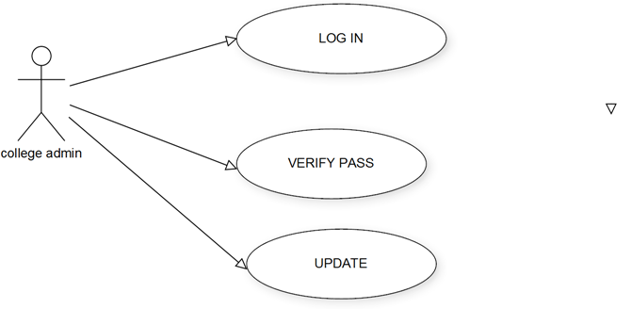

KSRTC Admin Use-Case Diagram

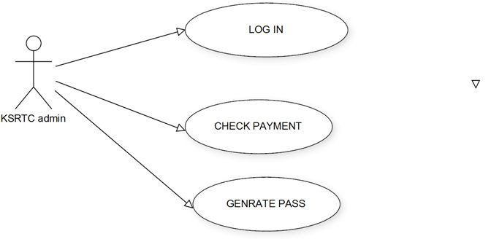

DATA FLOW DIAGRAMS

A data flow diagram is graphical tool used to describe and analyze movement of data through a system. These are the central tool and the basis from which the other components are developed. The transformation of data from input to output, may be described logically and independently of physical components associated with the system. These are known as the logical data flow diagrams.
The physical data flow diagrams show the actual implements and movement of data between people, departments and workstations. A full description of a system actually consists of a set of data flow diagrams. Using two familiar notations Yourdon, Gane and Sarson notation develops the data flow diagrams. Each component in a DFD is labeled with a descriptive name. Process is further identified with a number that will be used for identification purpose.
The development of DFD’s is done in several levels. Each process in lower level diagrams can be broken down into a more detailed DFD in the next level. The top-level diagram is often called context diagram. It consists of a single process bit, which plays vital role in studying the current system. The process in the context level diagram is exploded into other process at the first level DFD.
The idea behind the explosion of a process into more process is that understanding at one level of detail is exploded into greater detail at the next level.This is done until further explosion is necessary and an adequate amount of detail is described for analyst to understand the process.
Larry Constantine first developed the DFD as a way of expressing system requirements in a graphical from, this lead to the modular design.
A DFD also known as a “bubble Chart” has the purpose of clarifying system requirements and identifying major transformations that will become programs in system design. So it is the starting point of the design to the lowest level of detail. A DFD consists of a series of bubbles joined by data flows in the system.

Dfd Symbols:
In the DFD, there are four symbols
- A square defines a source(originator) or destination of system data
- An arrow identifies data flow. It is the pipeline through which the information flows.
- A circle or a bubble represents a process that transforms incoming data flow into outgoing data flows.
- An open rectangle is a data store, data at rest or a temporary repository of data.
Process that transforms data flow.

Source or Destination of data
Data flow
Data Store

Constructing A DFD:
Several rules of thumb are used in drawing DFD’s:
- Process should be named and numbered for an easy reference. Each name should be representative of the process.
- The direction of flow is from top to bottom and from left to right. Data traditionally flow from source to the destination although they may flow back to the source.One way to indicate this is to draw long flow line back to a source.An alternative way is to repeat the source symbol as a destination.Since it is used more than once in the DFD it is marked with a short diagonal.
- When a process is exploded into lower level details,they are numbered.
- The names of data stores and destinations are written in capital letters. Process and dataflow names have the first letter of each work capitalized.

Salient Features Of Dfd’s
- The DFD shows flow of data but no control loops and decisions are controlled but considerations do not appear on a DFD.
- The DFD does not indicate the time factor involved in any process whether the dataflows take place daily,weekly, monthly or yearly.
- The sequence of events is not brought out on the DFD.

TYPES OF DATA FLOW DIAGRAMS
- Current Physical
- Current Logical
- New Logical
- New Physical

CURRENT PHYSICAL:
In Current Physical DFD process label include the name of people or their positions or the names of computer systems that might provide some of the overall system-processing. Label includes an identification of the technology used to process the data. Similarly data flows and data stores are often labels with the names of the actual physical media on which data are stored such as file folders, computer files, business forms or computer tapes.
- CURRENT LOGICAL:
The physical aspects at the system are removed as much as possible so that the current system is reduced to its essence to the data and the processors that transform them regardless of actual physical form.
- NEW LOGICAL:
This is exactly like a current logical model. If the user is completely happy with the functionality of the current system but had problems with how it was implemented typically through the new logical model, will differ from current logical model while having additional functions, absolute function removal and inefficient flows recognized.
- NEW PHYSICAL:
The new physical represents only the physical implementation of the new system.

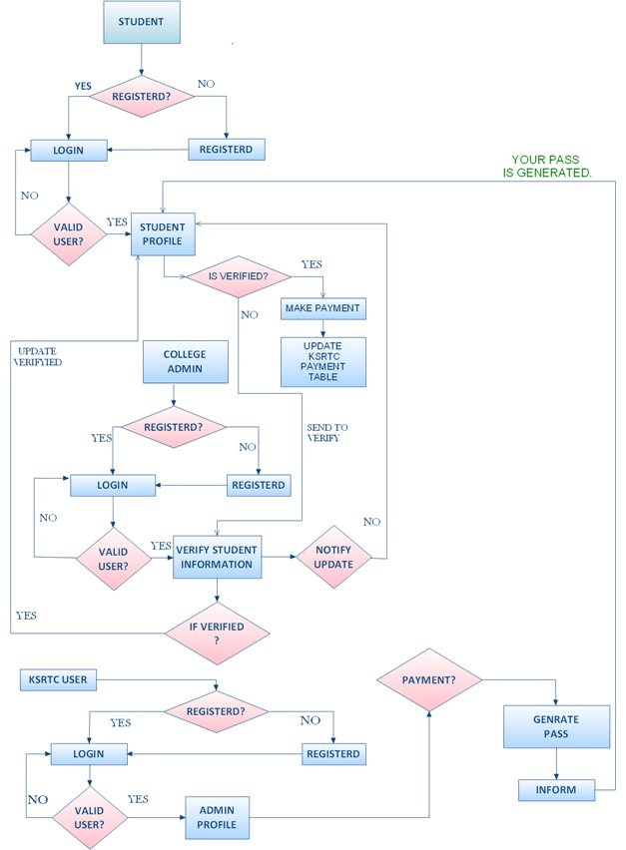
Dataflow Diagrams:

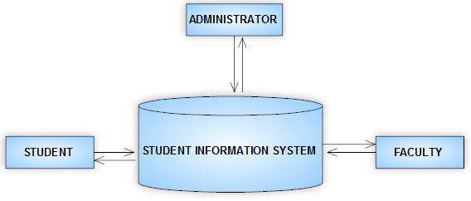

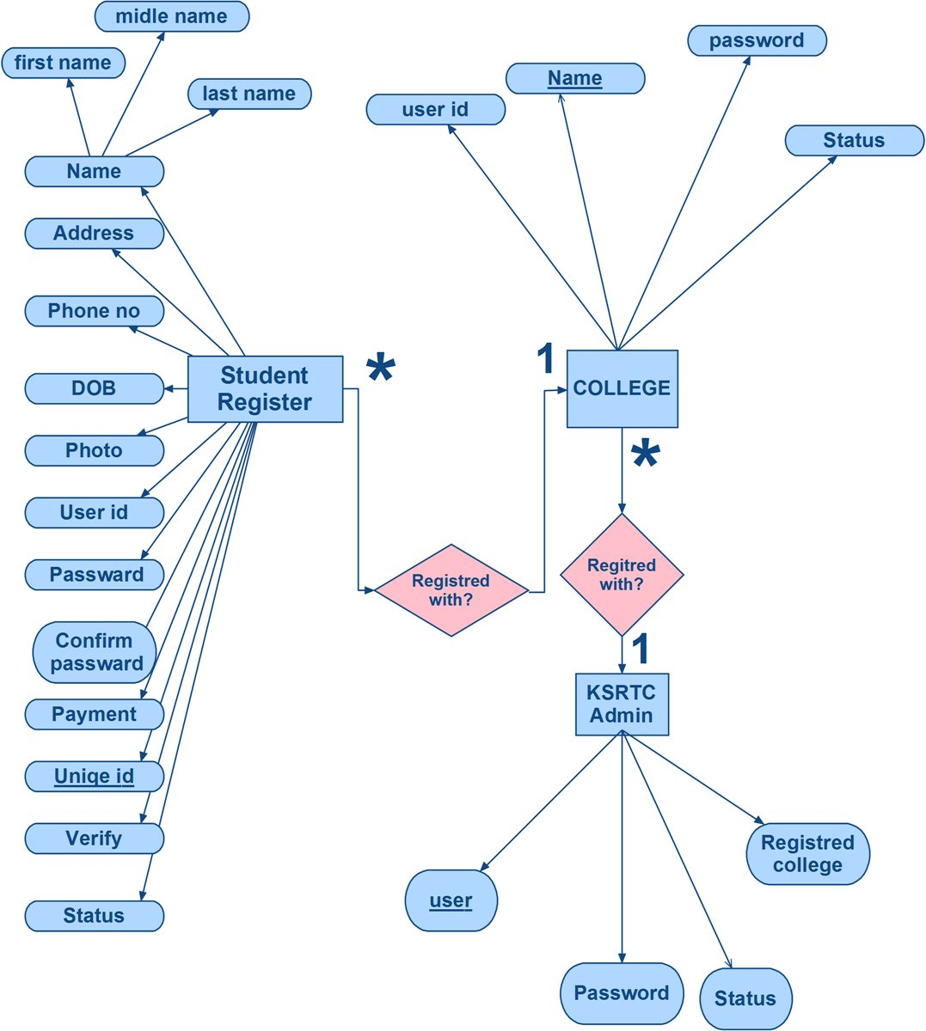
E R Diagram

SYSTEM IMPLEMENTATION AND SYSTEM TESTING
System Implementation:

Front End Code:
Home Page

<html>
<head>
</head>
<link href="style2.css" rel="stylesheet">
<body>
<div id="menu">
<br>
<h3 id="st"><h1>KSRTC Online Portal For E-Pass</h3>
<table width="537" border="0" id="sticky_navigation">

<tr>
<td width="236"><a href="login.html" id="menus"><img src="images/login.jpg" width="200" height="100" /></a></td>

<td width="285"><a href="registration.php" id="menus"><img src="images/registration.png" width="200" height="100" /></a></td>
</tr>
<br>
<tr id="st">
<td colspan="2" id="menu2"><p > <h2>E - Bus Pass automation system is a web application for students to get bus passes through online.
This system was intended to develop an application for K, S.R.T.C to perform functionalities like accessing the basic information
of a student from educational institutions,for authentication and provide Bus pass to a particular student without placing him/her
in a queue for a long time. This System keeps all information of all types of Student Bus pass.
.</p>
<p>&nbsp;</p></td><td>&nbsp;</td>
</tr>
</table>
</div>
</div>
</body>
</html>

Student Module Page:
<!DOCTYPE html PUBLIC "-//W3C//DTD XHTML 1.0 Transitional//EN" "http://www.w3.org/TR/xhtml1/DTD/xhtml1-transitional.dtd">
<html>
<head>
<title>Log in</title>
<meta http-equiv="Content-type" content="text/html; charset=UTF-8" />
<style type="text/css" media="all">
@import "style2.css";
</style>
<script language="JavaScript" type="text/javascript">
//--------------- LOCALIZEABLE GLOBALS ---------------
var d=new Date();
var monthname=new Array("January","February","March","April","May","June","July","August","September","October","November","December");
//Ensure correct for language. English is "January 1, 2004"
var TODAY = monthname[d.getMonth()] + " " + d.getDate() + ", " + d.getFullYear();
//--------------- END LOCALIZEABLE ---------------
</script>
</head>

<body>
<div id="menu2" align="center">
<table width="100%" >
<tr><td id="menu2">
<a href="index.php"><IMG src="upload/Refresh.png" width="50" height="50">Home</a>
<script language="JavaScript" type="text/javascript">
document.write(TODAY);
</script> &nbsp;&nbsp;
<span id="basicclock">
</span>
<script language="JavaScript" type="text/javascript">
function clock()
{
var digital = new Date();
var hours = digital.getHours();
var minutes = digital.getMinutes();
var seconds = digital.getSeconds();
var amOrPm = "AM";
if (hours > 11) amOrPm = "PM";
if (hours > 12) hours = hours - 12;
if (hours == 0) hours = 12;
if (minutes <= 9) minutes = "0" + minutes;
if (seconds <= 9) seconds = "0" + seconds;
dispTime = hours + ":" + minutes + ":" + seconds + " " + amOrPm;
document.getElementById("basicclock").innerHTML = dispTime;
setTimeout("clock()", 1000);
}
clock();
</script>
</p></td></tr></table>

<div id="content">
<div class="padding">
<div align="center"></div>
<br />
<form action="checkLogin.php" id="login" name="login" method="POST">
<table width="301" height="163" border="0" align="center" style="background:url(images/wood.jpg) no-repeat; " id="menu2">
<tr valign="bottom">
<td height="29" colspan="2" align="center"><span id="div_login"></span></td>
</tr>
<tr>
<td width="89" height="40" align="left"><h1 id="w">User Id</h1> </td>
<td width="202" align="left"><input type="text" name="username" id="username" tabindex="1"/></td>
</tr>
<tr>
<td height="35" align="left" class="formdata"><h1 id="w">Password</h1></td>
<td ><input type="password" name="password" id="password" tabindex="2" /></td>
</tr>
<tr>
<td height="49">&nbsp;</td>
<td><label >&nbsp;&nbsp;<input type="submit" value="&nbsp;&nbsp;&nbsp;LOGIN&nbsp;&nbsp;&nbsp;" style="background:url(images/url1.jpg)"/></a></label> </td><td><img src="images/lock.png" width="210" height="200"></td>
</tr>
</table>
</form>

</div>
</div>

<div id="footer"></div>

</div>

</body>
</html>

Student Profile view Page:

<!DOCTYPE html PUBLIC "-//W3C//DTD XHTML 1.0 Transitional//EN" "http://www.w3.org/TR/xhtml1/DTD/xhtml1-transitional.dtd">
<html xmlns="http://www.w3.org/1999/xhtml">
<head>
<meta http-equiv="Content-Type" content="text/html; charset=utf-8" />
<link href="style2.css" rel="stylesheet">
<title>E-PASS</title>
</head>
<body background="img/bk1.jpg"bgcolor="pink">
<div id="user" align="right"></div>
<center>
<div align="right" id="menu1"><a href="logout.php" title="Click to Log Out"> LogOut</a> </h4> </div>

<h1 align="left" id="menu1"> E-PASS <span class="usrname"> </span> </h1>

<h4 align="left" id="menu2">WELCOME </h4>
<table align="left">
<tr>
<td>
<marquee scroll="alternate" id="menus"><a href="#" >Latest Updates on Policies</a></marquee>

<li>

<a href="pass.php" ><ul class="contained" onmouseover="style='width:280px; margin:2 auto; margin-top:10px; min-height:10px; padding:5px; -moz-box-shadow: 10px 10px 12px #8569F3; -webkit-box-shadow: 10px 10px 12px #8569F3; box-shadow:10px 10px 12px #8569F3;'" onmouseout="style='width:200px; margin:2 auto; margin-top:10px; min-height:10px; padding:5px; -moz-box-shadow: 10px 10px 12px #8569F3;-webkit-box-shadow: 10px 10px 12px #8569F3;box-shadow:10px 10px 12px #8569F3;'" id="menus">Click here to Apply Pass</ul></a>

</li>
<li>

<a href="payment.php" ><ul class="contained" onmouseover="style='width:280px; margin:2 auto; margin-top:10px; min-height:10px; padding:5px; -moz-box-shadow: 10px 10px 12px #8569F3; -webkit-box-shadow: 10px 10px 12px #8569F3; box-shadow:10px 10px 12px #8569F3;'" onmouseout="style='width:200px; margin:2 auto; margin-top:10px; min-height:10px; padding:5px; -moz-box-shadow: 10px 10px 12px #8569F3;-webkit-box-shadow: 10px 10px 12px #8569F3;box-shadow:10px 10px 12px #8569F3;'" id="menus">Click here to Make Payment</ul></a>

</li>
</td>
</tr>
</table>
</center>
</body>

</html>

Apply Pass Page
<?php
session_start();?>
<link href="style2.css" rel="stylesheet">

<script type="text/javascript" src="jquery-1.4.2.js"></script>
<script type="text/javascript" src="ui/jquery.ui.core.js"></script>
<script type="text/javascript" src="ui/jquery.ui.widget.js"></script>
<script type="text/javascript" src="ui/jquery.ui.datepicker.js"></script>
<link type="text/css" href="demos.css" rel="stylesheet" />
<script type="text/javascript">
$(function() {
$('#bdate').datepicker({
changeMonth: true,
changeYear: true,
yearRange: '1900:2010'
});
$('#txtjoin').datepicker({
changeMonth: true,
changeYear: true,
});
});
</script>

<script type="text/javascript">
function isNumberKey(evt)
{

var charCode = (evt.which) ? evt.which : event.keyCode
//alert(charCode);
if (charCode > 63 && charCode < 92 )
{
return true;
}
else if (charCode > 96 && charCode < 123 )
{
return true;
}
else
{
alert("should be alphabet");
return false;
}
}
function validate()
{
if(document.form1.fname.value=="")
{
alert("Enter First Name");
document.form1.fname.focus();
return false;
}
if(document.form1.lname.value=="")
{
alert("Enter Last Name");
document.form1.lname.focus();
return false;
}
if(document.form1.emailid.value=="")
{
alert("Enter Email ID");
document.form1.emailid.focus();
return false;
}
ml = document.form1.emailid.value;
pos1 = ml.indexOf("@")
pos = ml.indexOf(" ")
pos2 = (pos1+1)
server = ml.substring(pos2);
server_pos = server.lastIndexOf(".")
reqtype = server.substring(server_pos+1)
type_end = reqtype.substring(reqtype.length-1)

if(ml.length<8)
{
document.form1.emailid.focus();
document.form1.emailid.select();
alert("emailid length cannot be less than 8 characters");
return false;
}
if(ml.indexOf("@")==-1)
{
document.form1.emailid.focus();
document.form1.emailid.select();
alert("The emailid Address must contain '@' sign");
return false;
}
if(pos1<1)
{
document.form1.emailid.focus();
document.form1.emailid.select();
alert("emailid address cannot start with '@' sign");
return false;
}
if(ml.indexOf(".")==-1)
{
document.form1.emailid.focus();
document.form1.emailid.select();
alert("The emailid Address must contain '.' sign");
return false;
}
if(pos!=-1)
{
document.form1.emailid.focus();
document.form1.emailid.select();
alert("The emailid Address cannot contain spaces");
return false;
}
if(server.indexOf("@")!=-1)
{
document.form1.emailid.focus();
document.form1.emailid.select();
alert("A valid emailid must contain only one '@' sign");
return false;
}
if(server.indexOf(".")==0)
{
document.form1.emailid.focus();
document.form1.emailid.select();
alert("There should some text between '@' and '.' sign");
return false;
}
if(reqtype=="")
{
document.form1.emailid.focus();
document.form1.emailid.select();
alert("emailid Id should end with character(like .com,.net,.org)");
return false;
}
if(type_end.toUpperCase()<"A" || type_end.toUpperCase()>"Z")
{
document.form1.emailid.focus();
document.form1.emailid.select();
alert("emailid Id should not end with number or symbol");
return false;
}

if(document.form1.password.value=="")
{
alert("Enter Password");
document.form1.password.focus();
return false;
}
if(document.form1.confpass.value=="")
{
alert("Please confirm the Password");
document.form1.confpass.focus();
return false;
}
if(document.form1.address.value=="")
{
alert("Enter the Address");
document.form1.address.focus();
return false;
}
if(document.form1.city.value=="")
{
alert("Enter the City");
document.form1.city.focus();
return false;
}
if(document.form1.zip.value=="")
{
alert("Enter the Zip");
document.form1.zip.focus();
return false;
}
if(document.form1.phone.value=="")
{
alert("Enter Phone No");
document.form1.phone.focus();
return false;
}
if(document.form1.mobile.value=="")
{
alert("Enter Mobile Number");
document.form1.mobile.focus();
return false;
}
}
</script>
<body>

<form id="form1" name="form1" method="post" enctype="multipart/form-data" action="passcheck.php" onsubmit="return validate()">
<a href="Home.php" title="Click go to Home"> Home</a><br>

</div>

<table width="522" border="0" align="center">
<tr bgcolor="#CCFFFF">
<th height="33" scope="row" align="left">User information:</th>
<td>&nbsp;</td>
</tr>
<tr>
<th width="170" height="33" scope="row">Applicaation ID</th>
<td width="247">
<label for="ApplicaationID"></label>
<input name="ApplicaationID" type="" id="ApplicaationID" value="<?php echo uniqid()?>"/>
</td>
</tr>
<tr>
<th width="170" height="33" scope="row">First Name</th>
<td width="247">
<label for="lname"></label>
<input name="fname" type="text" id="fname" size="35" onKeyPress="return isNumberKey(event)"/>
</td>
</tr>
<tr>
<th height="37" scope="row">Last Name
<label for="lname"></label></th>
<td><input name="lname" type="text" id="lname" size="35" onKeyPress="return isNumberKey(event)" /></td>
</tr>
<tr>
<th height="36" scope="row">Email Id</th>
<td><label for="email"></label>
<input name="email" type="text" id="email" size="35" /></td>
</tr>
<tr>
<th height="36" scope="row">Gender</th>
<td>
<input type="radio" name="gender"value="Male">Male

<input type="radio" name="gender"value="Female">Female
</td>

</tr>
<tr>
<th height="37" scope="row">
<label>Date of birth</label></th>
<td><input type="text" name="bdate"id="bdate" readonly="yes"> </td>

</tr>
<tr>
<th width="170" height="33" scope="row">college name</th>
<td width="247">
<label for="collegename"></label>
<input name="collegename" type="text" id="collegename" size="35" onKeyPress="return isNumberKey(event)"/>
</td>
</tr>

<tr align="left" bgcolor="#CCFFFF">
<th height="29" colspan="2" scope="row"><u>Contact information</u></th>
</tr>
<tr>
<th height="37" scope="row">Address</th>
<td><textarea name="address" cols="35" id="address"></textarea></td>
</tr>
<tr>
<th height="37" scope="row">City</th>
<td><input name="city" type="text" id="city" size="35" /></td>
</tr>
<tr>
<th height="37" scope="row">Zip code</th>
<td><input name="zipcode" type="text" id="zipcode" size="35" onKeypress="if (event.keyCode < 45 || event.keyCode > 57) event.returnValue = false;"/></td>
</tr>
<tr>
<th height="37" scope="row">Phone No</th>
<td><label for="date"></label>
<input name="phone" type="text" id="phone" size="35" onKeypress="if (event.keyCode < 45 || event.keyCode > 57) event.returnValue = false;"/></td>
</tr>
<tr>
<th scope="row">Mobile No</th>
<td><label for="mobile"></label>
<input name="mobile" type="text" id="mobile" size="35" onKeypress="if (event.keyCode < 45 || event.keyCode > 57) event.returnValue = false;"/></td>
</tr>

<tr align="left" bgcolor="#CCFFFF">
<th height="29" colspan="2" scope="row"><u>Bus Route information</u></th>
</tr>
<tr>
<th height="37" scope="row">From</th>
<td><input name="From" cols="35" id="From"></textarea></td>
</tr>
<tr>
<th height="37" scope="row">To</th>
<td><input name="To" type="text" id="To" size="35" /></td>
</tr>
<tr>
<th width="170" height="33" scope="row">student photos</th>
<td width="247">
<label for="studentphotos"></label>
<input name="studentphotos" type="file" id="studentphotos" class=""/>
</td>
</tr>
<tr>
<th width="170" height="33" scope="row">Address Prof</th>
<td width="247">
<label for="Address Prof"></label>
<input name="AddressProf" type="file" id="AddressProf" class=""/>
</td>
</tr>

<tr>
<th scope="row">&nbsp;</th>
<td><br /> <input type="submit" name="submit" id="submit" value="Register" /></td>
</tr>
</table>
</form>

<p>&nbsp;</p>
<br />

</div>

</div><body><html>
Student view php Page:
<?php
include("dbconnection.php");
$ApplicaationID = $_POST["ApplicaationID"];
echo"$ApplicaationID";
$fname = $_POST["fname"];
$lname = $_POST["lname"];
$email = $_POST["email"];
$gender = $_POST["gender"];
$bdate = $_POST["bdate"];
$m = substr($bdate,0,2);
$d = substr($bdate,3,2);
$y = substr($bdate,6,4);
$bdate = $y."-".$m."-".$d;
$collegename=$_POST["collegename"];
$address = $_POST["address"];
$city= $_POST["city"];
$zipcode= $_POST["zipcode"];
$phone= $_POST["phone"];
$mobile= $_POST["mobile"];
$From=$_POST["From"];
$To= $_POST["To"];
$studentphotos = "upload/".$_FILES['studentphotos']['name'];
$AddressProf = "upload/".$_FILES['AddressProf']['name'];

if((move_uploaded_file($_FILES['studentphotos']['tmp_name'],$studentphotos)) && (move_uploaded_file($_FILES['AddressProf']['tmp_name'],$AddressProf)))
{

$sql=mysql_query("INSERT INTO `e-pass`.`pass` (
`Applicaation ID` ,
`fname` ,
`lname` ,
`email` ,
`gender` ,
`bdate` ,
`collegename` ,
`address` ,
`city` ,
`zipcode` ,
`phone` ,
`mobile` ,
`From` ,
`To` ,
`studentphotos` ,
`AddressProf`
) values('$ApplicaationID','$fname','$lname','$email','$gender','$bdate','$collegename','$address','$city','$zipcode','$phone','$mobile','$From','$To','$studentphotos','$AddressProf')");
mysql_query($sql);
?>
<script>
alert("Pass is Submited Successful");
document.location="home.php";
</script>
<?php
}
else
{
echo"retry";
}?>
Payment Page :
<!DOCTYPE html PUBLIC "-//W3C//DTD XHTML 1.0 Transitional//EN" "http://www.w3.org/TR/xhtml1/DTD/xhtml1-transitional.dtd">
<html xmlns="http://www.w3.org/1999/xhtml">
<head>
<meta http-equiv="Content-Type" content="text/html; charset=utf-8" />
<title>E-PASS</title>
</head>
<link href="style2.css" rel="stylesheet">
<script>
function showUser(str)
{

if (str == "")
{
document.getElementById("txtHint").innerHTML = "Enter Your Valid Application id";
return;
}

if (window.XMLHttpRequest)
{
// code for IE7 + , Firefox, Chrome, Opera, Safari
xmlhttp = new XMLHttpRequest();
}
else
{
// code for IE6, IE5
xmlhttp = new ActiveXObject("Microsoft.XMLHTTP");
}

xmlhttp.onreadystatechange = function()
{
if (xmlhttp.readyState == 4 && xmlhttp.status == 200)
{
document.getElementById("txtHint").innerHTML = xmlhttp.responseText;
}
}
xmlhttp.open("GET", "findacc.php?appid=" + str, true);
xmlhttp.send();
}

function validated(str)
{

if (str == "")
{
document.getElementById("err").innerHTML = "...";
return;
}

if (window.XMLHttpRequest)
{
// code for IE7 + , Firefox, Chrome, Opera, Safari
xmlhttp = new XMLHttpRequest();
}
else
{
// code for IE6, IE5
xmlhttp = new ActiveXObject("Microsoft.XMLHTTP");
}

xmlhttp.onreadystatechange = function()
{
if (xmlhttp.readyState == 4 && xmlhttp.status == 200)
{
document.getElementById("err").innerHTML = xmlhttp.responseText;
}
}
xmlhttp.open("GET", "validate.php?appid=" + str, true);
xmlhttp.send();
}

</script>
<body >

<center><h1 align="left" id="menus">PAYMENT OF PASS</h1>
<hr color="blue">
<a href="home.php" id="menus"> HOME</a><br>

<br>
<div id="menu2">

<form id="payment_form" class="" action="paymentcheck.php" method="POST" enctype="multipart/form-data" style="bgcolor:#B3E7E;">
<table border="0" class="labelname1" align="center" id="menus">
<tr>

<td><label>Application id:</label></td>
<td><input name="appid" id="appid" type="text" value="" maxlength="40" onBlur="showUser(this.value)">
</td><td color="red"><div id="txtHint" bgcolor="red"> </div></td>

<td>Note: as Assinged by the time of Pass Registration </td>
</tr>
<tr>

<td><label>Name</label></td>
<td><input name="name" id="name" type="text" maxlength="40"></td>

</tr>
<tr>

<td><label>Credit card or Debit card or ATM card Number>:</label></td>
<td><input name="card" id="card" type="text" value="" maxlength="40"></td>
<td>ex: 10 or 15 digit card Number </td>
</tr>
<tr>
<td><label>Security Pin:</label></td>
<td><input name="pin" id="pin" type="password" value="000" maxlength="40"></td>

</tr>

<tr>
<td><label>Pass Amount:</label></td>
<td><input name="amount" id="amount" type="text" value="1455" maxlength="40"></td>

</tr>

<tr><td>&nbsp;
</td><td><input id="submit" type="submit" value="Make Payment" /></td>
<td>&nbsp;
</td>
</tr>
</table>

</form>

</div>
<hr>
<br>
</center>
</body>
</html>

Payment php Page :
<?PHP

include('dbconnection.php');
$appid=$_POST['appid'];
$name=$_POST['name'];
$card=$_POST['card'];
$pin=$_POST['pin'];
$amount=$_POST['amount'];
if(isset($appid))
{
echo"Setting";
}
$res=mysql_query("SELECT *
FROM `pass`
WHERE `Applicaation ID` = '$appid'");
if($res)
{
mysql_query("insert into payment (appid,name,card,pin,amount) values('".$appid."','".$name."','".$card."','".$pin."','".$amount."')");

$sql="update pass set payment ='$amount' WHERE `Applicaation ID` = '$appid'";
mysql_query($sql);

echo "PAYMENTIS IS DONE ";

}
else
{

echo "PAYMENTIS IS NOT DONE ";

}

?>
<hr>
<script>
alert("PAYMENTIS IS DONE");
document.location="home.php";

</script>

<a href="Home.php">Back</a>

Admin Page
<html xmlns="http://www.w3.org/1999/xhtml">
<head>
<meta http-equiv="Content-Type" content="text/html; charset=utf-8" />
<title></title>
</head>
<link href="style2.css" rel="stylesheet">
<body onload="checkCookie();">
<center>
<div align="right" ><div id="menu1"> |<a href="logout.php" title="Click to Log Out"> LogOut</a>| |<a href="admin1.php">REFRESH RECORDS</a> |</h4> </div></div>
<div align="center" id="menu1"><h1> E-pass </h1><span class="usrname"> <br>Ease of getting pass through online service....</span> </div>
<td>
<marquee behaviour="alternate" id="menu2" direction=""right"" width=200 height=20 scrolldelay="1" SCROLLAMOUNT="10" onmouseover="this.stop();" onmouseout="this.start();"><a href=#" >Latest Updates on Policies</a></marquee>
</br>
</br>
</td>
<table align="left" width="800" id="menu1" >
<td>
<table align="right" width="800">
<tr>
<td>
<?php
include('dbconnection.php');
$sql="select * from pass";
$res=mysql_query($sql);
?>
</td>
<tr>

<table width="567" border="1" class="img" align="center" id="menu2" >
<thead>

<tr id="menu2">
<th scope="row">Application ID</th>
<th width="79"><P>NAME</th>
<th width="75"><p>LNAME</th>
<th width="55"><p>GENDE</th>
<th width="55"><p>BDATE</th>
<th width="55"><p>COLLEGE NAME</th>
<th width="139"><p>CITY </th>
<th width="139"><p>MOBILE NO </th>
<th width="139"><p>Address</th>
<th width="139"><p>STUDENT PHOTO</th>
<th width="139"><p>Address Prof</th>
<th width="139"><p>PAYMENT</th>
<th width="139"><p>FOrWAD PASS</th>
<th width="139"><p>DELETE PASS</th>
</tr>
<?php
while($row=mysql_fetch_array($res))
{
?>
<tr>
<td scope="row"><?php echo $row["Applicaation ID"];?>&nbsp;</td>
<td scope="row"><?php echo $row["fname"];?>&nbsp;</td>
<td scope="row"><?php echo $row["lname"];?>&nbsp;</td>
<td><?php echo $row["gender"];?>&nbsp;</td>
<td><?php echo $row["bdate"];?> &nbsp;</td>
<td><?php echo $row["collegename"];?> &nbsp;</td>
<td><?php echo $row["city"];?> &nbsp;</td>
<td><?php echo $row["mobile"];?> &nbsp;</td>
<td><?php echo $row["address"];?> &nbsp;</td>

<td><img class="img" src="<?php echo $row["studentphotos"];?>" width="100" height="100">&nbsp;</td>
<td><img class="img" src="<?php echo $row["AddressProf"];?>" width="100" height="100">&nbsp;</td>
<td><?php echo $row["payment"];?> &nbsp;</td>

<td align="center">
<a align="center" href="update.php?ApplicaationID=<?php echo $row["Applicaation ID"];?>" onClick="return confirm('Are U Sure Want to Update')">
<IMG src="up.png" width="60" height="50"></a></td>
<td align="center">
<a align="center" href="DELETE.php?ApplicaationID=<?php echo $row["Applicaation ID"];?>" onClick="return confirm('Are U Sure Want to DELETE')">
<IMG src="D.png" width="30" height="20"></a></td>
</tr>
</tr>
<?php
} ?>

</td>
</tr>
</table>
</td>
</tr>
</table>
</br>

</br>
</center>
</br>

</br>
</body>

</html>

KSRTC ADMIN PAGE

<!DOCTYPE html PUBLIC "-//W3C//DTD XHTML 1.0 Transitional//EN" "http://www.w3.org/TR/xhtml1/DTD/xhtml1-transitional.dtd">
<html xmlns="http://www.w3.org/1999/xhtml">
<head>
<meta http-equiv="Content-Type" content="text/html; charset=utf-8" />
<title></title>
</head>
<style>
body {
background-image: url("s.jpg");
background-repeat: no-repeat;
background-attachment: fixed;
}
.contained
{ width:200px;
margin:2 auto;
margin-top:10px;
min-height:10px;
padding:5px;
-moz-box-shadow: 10px 10px 12px #F07B7B;
-webkit-box-shadow: 10px 10px 12px #F07B7B;
box-shadow:10px 10px 12px #F07B7B;
}

.contain
{ width:500px;
margin:0 auto;
border:10px green dashed;
margin-top:20px;
min-height:300px;
padding:5px;
-moz-box-shadow: 6px 10px 12px #888;
-webkit-box-shadow: 6px 6px 12px #888;
box-shadow:6px 10px 12px #888;
}
.right
{
position: absolute;
right: 0px;
width: 500px;
background-color: #b0e0e6;
}

a{
background:#D3FCCD;
width: 400px;
height: 300px;
-moz-box-shadow: 6px 10px 12px #888;
-webkit-box-shadow: 6px 6px 12px #888;
box-shadow:6px 10px 12px #888;
}
.img{
background:#D3FCCD;
width: 100px;
height: 100px;
-moz-box-shadow: 6px 10px 12px #888;
-webkit-box-shadow: 6px 6px 12px #888;
box-shadow:6px 10px 12px #888;
}
.img1{
background:#D3FCCD;
align:center;
width: 800px;
height: 200px;
-moz-box-shadow: 6px 10px 12px #888;
-webkit-box-shadow: 6px 6px 12px #888;
box-shadow:6px 10px 12px #888;
}
input { font-size:18px; color:white; background:green; padding:10px; width:200px; margin-top:25px;}

.labelname { font-size:20px; font-weight:bold; font-family:Copperplate Gothic Bold,Cambria (Headings),Bradley Hand ITC; color:#33C; padding:10px; -moz-box-shadow: 6px 10px 12px #888; -webkit-box-shadow: 6px 6px 12px #888; box-shadow:6px 10px 12px #888; }

.labelname1 { font-size:25px; font-weight:bold; font-family:Cambria (Headings),Bradley Hand ITC; color:GREEN; padding:10px; -moz-box-shadow: 6px 10px 12px #888; -webkit-box-shadow: 6px 6px 12px #888; box-shadow:6px 10px 12px #888; alighn="right" }

#submit { width:220px; height:40px;font-weight:bold; padding:2px; background-color:brown; align:right; font-size:22px;}

h1 { color:white; font-size:22px; background-color:#CCC; padding:10px; }

h2 { color:white; font-size:22px; background-color:pink; padding:10px; }
h3 { color:#654; font-size:15px;}
h4 { color:#333; font-size:18px;background-color:pink;}

</style>

<script>$(function(){$( document ).tooltip();}); </script>

<style>label{ display: inline-block;width: 8em;}</style>
<body onload="checkCookie();">
<center>
<div align="right"><div id="submit"> |<a href="logout.php" title="Click to Log Out"> LogOut</a>| </h4> </div></div>

<h1 align="left"> e-pass <span class="usrname"> </span> </h1>

<h4 align="left" >E-PASS SERVICE</h4>

<table align="left" width="800">

<td></td>
<td>
<table align="right" width="800">
<tr>
<td>

<?php
include('dbconnection.php');
$sql="select * from ksrtcadmin";
$res=mysql_query($sql);

?>

<body>
<p><a href="ksrtc.php">REFRESH RECORDS</a> </p>
<tr>
<td>
<marquee behaviour="alternate" scroll="alternate" class="contained" ><a href="#">Latest Updates on Policies</a></marquee>

</td>
<table width="567" border="4" class="img" align="center">
<thead>

<tr>
<th scope="row">Application ID</th>
<th width="79"><P>NAME</th>
<th width="75"><p>LNAME</th>
<th width="55"><p>GENDE</th>
<th width="55"><p>BDATE</th>
<th width="55"><p>COLLEGE NAME</th>
<th width="139"><p>CITY </th>
<th width="139"><p>MOBILE NO </th>
<th width="139"><p>Address</th>
<th width="139"><p>From</th>
<th width="139"><p>To</th>
<th width="139"><p>STUDENT PHOTO</th>
<th width="139"><p>Address Prof</th>
<th width="139"><p>PAYMENT</th>
<th width="139"><p>GENRATE PASS</th>
<th width="139"><p>DELETE PASS</th>
</tr>
<?php
while($row=mysql_fetch_array($res))
{
?>
<tr>
<td scope="row"><?php echo $row["Applicaation ID"];?>&nbsp;</td>
<td scope="row"><?php echo $row["fname"];?>&nbsp;</td>
<td scope="row"><?php echo $row["lname"];?>&nbsp;</td>
<td><?php echo $row["gender"];?>&nbsp;</td>
<td><?php echo $row["bdate"];?> &nbsp;</td>
<td><?php echo $row["collegename"];?> &nbsp;</td>
<td><?php echo $row["city"];?> &nbsp;</td>
<td><?php echo $row["mobile"];?> &nbsp;</td>
<td><?php echo $row["address"];?> &nbsp;</td>
<td><?php echo $row["From"];?> &nbsp;</td>
<td><?php echo $row["To"];?> &nbsp;</td>

<td><img class="img" src="<?php echo $row["studentphotos"];?>" width="100" height="100">&nbsp;</td>
<td><img class="img" src="<?php echo $row["AddressProf"];?>" width="100" height="100">&nbsp;</td>
<td><?php echo $row["payment"];?> &nbsp;</td>

<td align="center">
<a align="center" href="genrate.php?ApplicaationID=<?php echo $row["Applicaation ID"];?>"
onClick="return confirm('Are U Sure Want to Update')'.$row["Applicaation ID"])">
<IMG src="up.png" width="100" height="50"></a></td>
<td align="center">
<a align="center" href="DELETE.php?Applicaation ID=<?php echo $row["Applicaation ID"];?>"
onClick="return confirm('Are U Sure Want to DELETE')">
<IMG src="D.png" width="100" height="50"></a></td>
</tr>
</tr>
<?php
} ?>

</td>
</tr>
</table>
</td>
</tr>
</table>
</center>
</body>
</html>

TESTING:
Testing is a process to show the correctness of the program. Testing is needed to show completeness, t improve the quality of the software and to provide the maintenance aid. Some testing standards are therefore necessary reduce the testing costs and operation time.
Testing software extends throughout the coding phase and it represents the ultimate review of configurations, design and coding. Based on the way the software reacts to these testing, we can decide whether the configuration that has been built is study or not. All components of an application are tested, as the failure to do so many results in a series of bugs after the software is put to use.
Black box testing
Black box testing also called behavioral testing, focuses on the functional requirements of software. This testing approach enables the software engineer to derive the input conditions that will fully exercise all requirements for a program. Blackbox testing attempts to find the errors like
- Incorrect or missing functions
- Interface errors
- Errors in data structures or external database access
- Behavior or performance errors
- Initialization and termination errors
In Black box testing software is exercised over a full range of inputs and outputs are observed for correctness.
White box testing
Whitebox testing is also called Glassbox testing is a test case design control; structure of the procedural design to derive test cases using Whitebox testing method, the software engineer can derive the test cases that guarantee that all independent paths within the module have been exercised at least once. Exercise all logic decisions on their true or false sides. Execute all loops at their boundaries and within their operational bounds. Exercise internal data structure to ensure their validity.
Software testing strategies
Testing involves
- Unit testing
- Integration testing
- Acceptance testing
The first level of test is unit testing. The purpose of unit testing is to ensure that each program is fully tested.
The second step is integration testing. In this individual program units or programs are integrated and tested as a complete system to ensure that the software requirements are met.
Acceptance Testing involves planning and the execution of various types of tests in order to demonstrate that the implemented software system satisfies the requirements. Finally our project meets the requirements after going through all the levels of testing.
Testing the application
Application should be thoroughly tested before releasing it into the market.
Testing will show if the application is delivering the expected results. In this case we have given some wrong values to the application so that we can counter the errors produced by the application in such a case. Next topic is test cases, where 10 test cases are considered and checked if the test results are positive or not.

Test CASES (front end)

S.No | Test case | Condition | Expected Output
1 | Get Systems | Input Domain name | Print list of all system in current domains & response time
2 | Get User | Input Domain name | System id, user id, port no, domain name
3 | Get Processes details | Select process | Output the details of processes
4 | Get modules details | Select process & select thread opt | Details of modules
5 | Get thread details | Select process & select thread opt | Details of threads
6 | Stop the processes | System id, user id, password | Process close
7 | Stop the system | System id | System close

- TESTING ANALYSIS

S.No | Testing object | Expected value | Simulated value | Explanation | Remarks
1 | User name & Password | AEIND  GUEST | AEIND  GUEST | Equal of expected and simulated values | Pass
2 | User name & Password | AEIND  GUEST | AEIND  GUEST | Unequal of expected and simulated value | Fail
4 | Start time and end time | 11:03:05 | 11:03:05 | Equal of these times | Pass
5 | Start date and end date | 02/01/2015 | 02/01/2015 | Equal of these dates | Pass

SCREEN SHOTS
FRONT END SCREEN:
MAIN SCREEN:
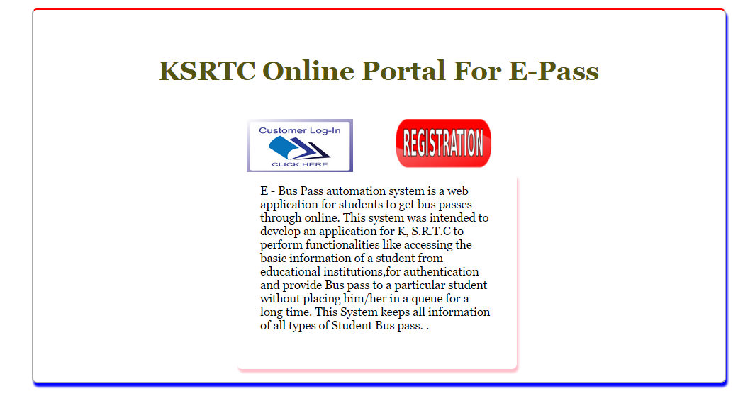

This is main page for front end.

Login Page
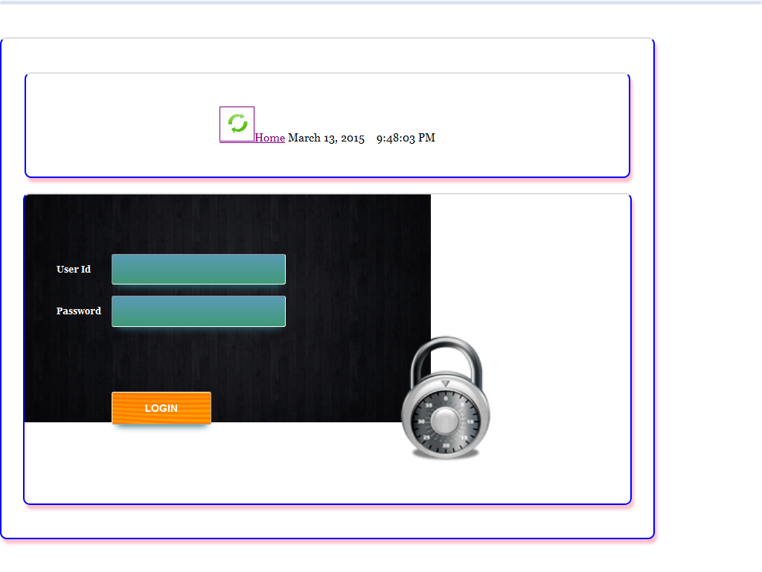

Student Home Page:
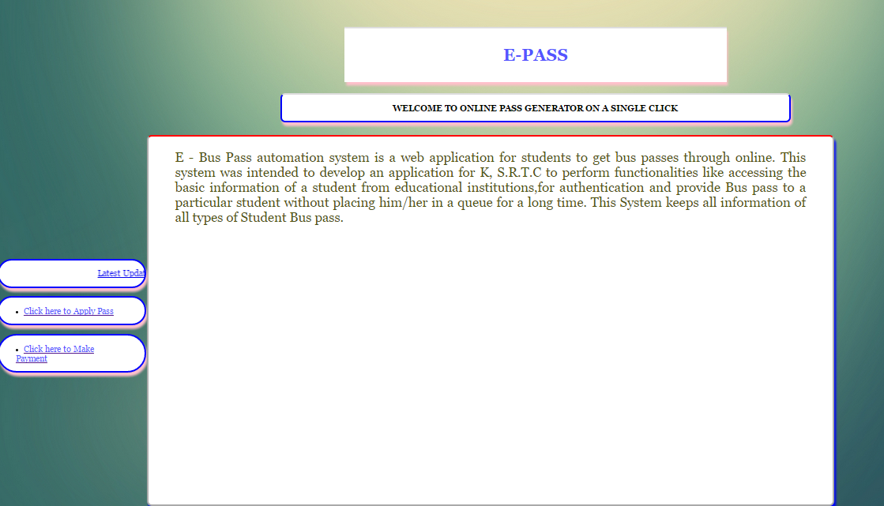

Apply Pass Menu in Page
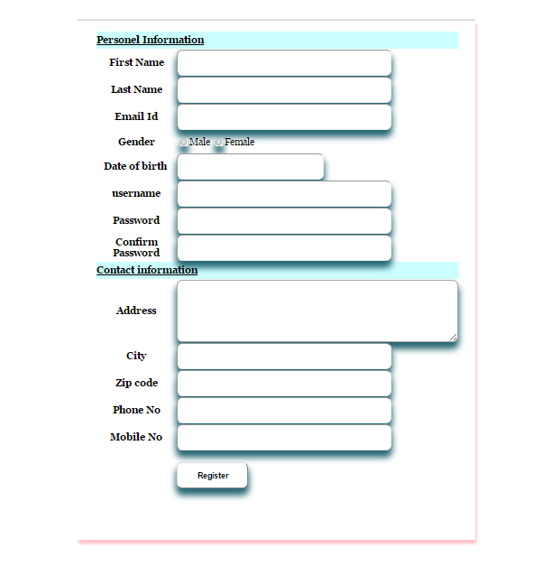

Payment Page
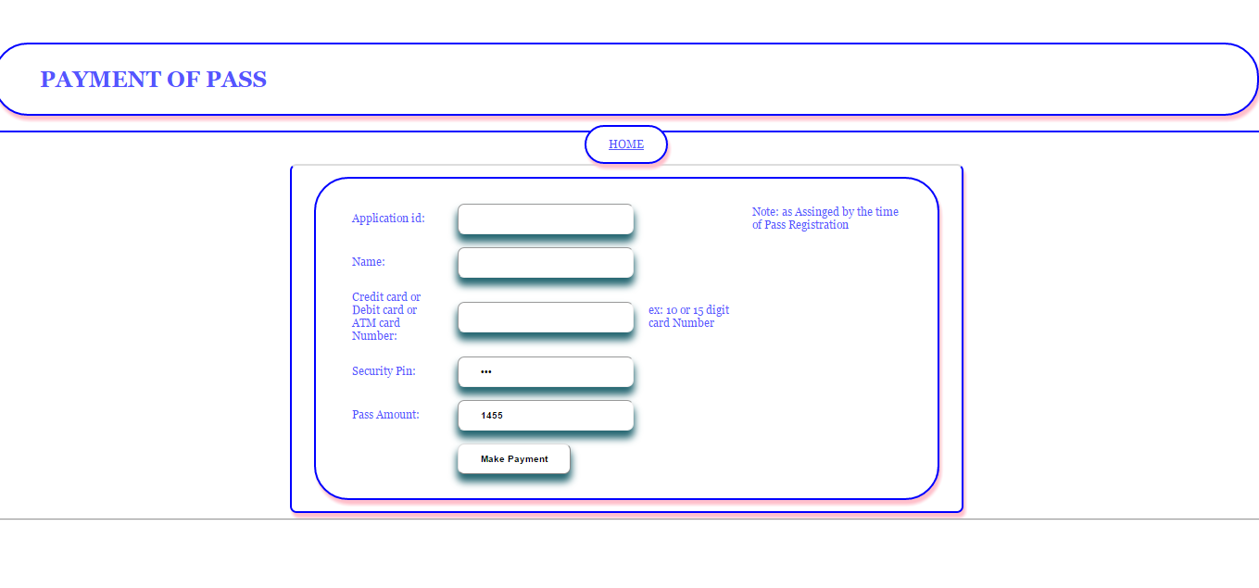

College Admin Page
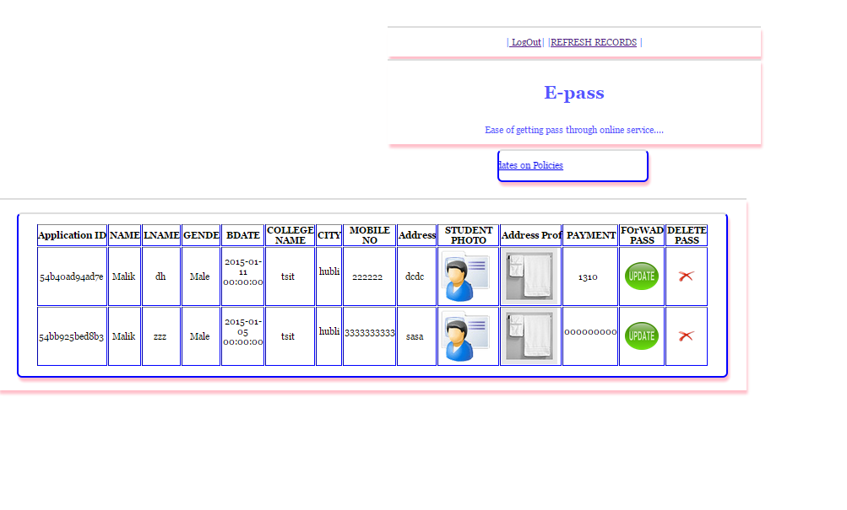
KSRTC Admin Page
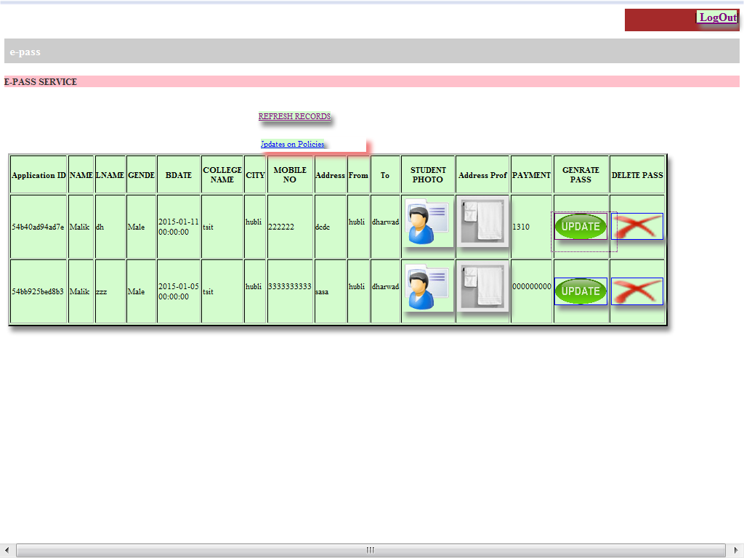
Pass Generation Page

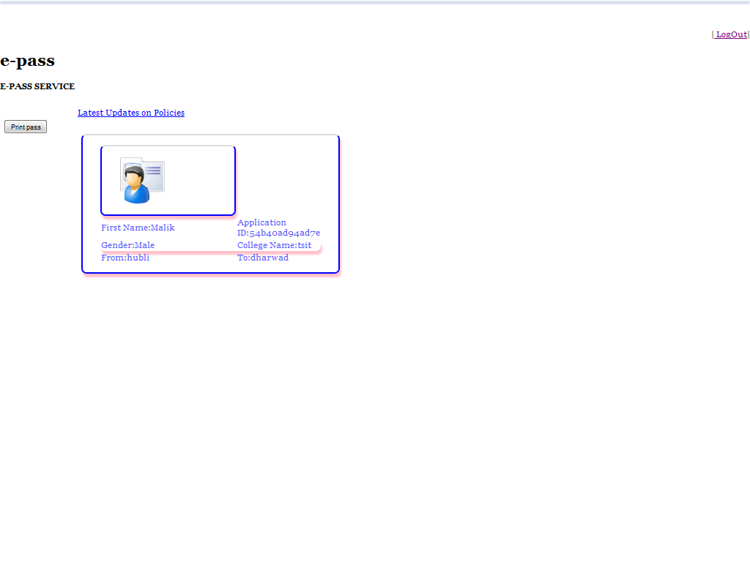

References

1) PHP an Mysql - THE COMPLETE REFERENCE, 5TH EDITION
2) www.oracle.com
3) www.wikipedia.com
4) www.w3schools.com
5) www.tutorialspoint.com

